**Networking**

Networking is an essential aspect of LInux system administration. Here are some basic networking commands that is useful for administrator:-

* **ifconfig**

ifconfig is used to view network interfaces.

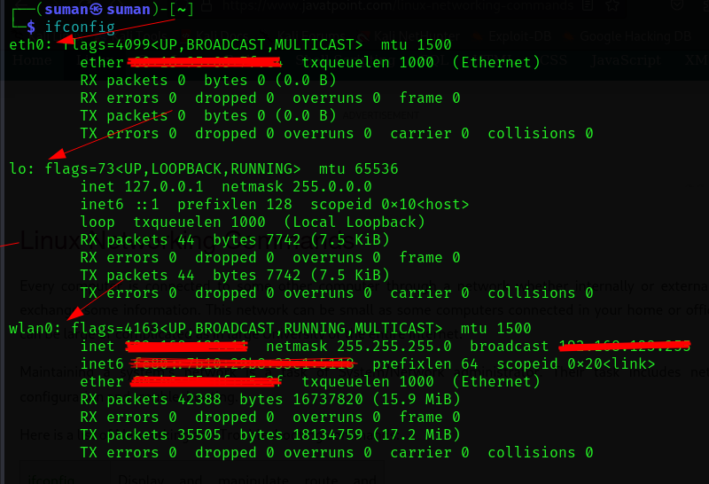

1. Eth0 => Ethernet (wired connection)
2. lo => Loopback (local)
3. wlan0 => wireless Lan

* **ping**

pingcommand is a tool for diagnosing connectivity issues, monitoring network performance, and checking server availability.

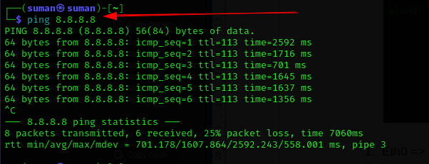

* **Interface up/down**

Here the process to do a network interface up or down in linux:-

To bring an interface down:-

**sudo ifconfig <ethernet interface> down**

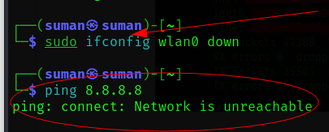

**To bring interface up:-**

**sudo ifconfig <ethernet interface> up**

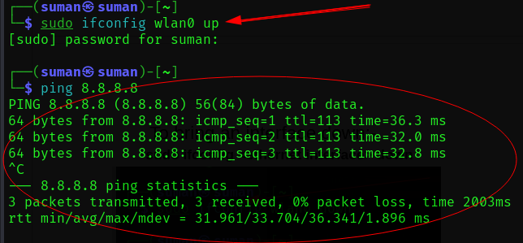

* **nslookup**

The nslookup command is used for querying the Domain Name system (DNS) to obtain name or ip address information. It’s a helpful tool for troubleshooting and diagnosing DNS-related issues.

Here the basic syntax of nslookup:-

**sudo nslookup <domain or ip address>**

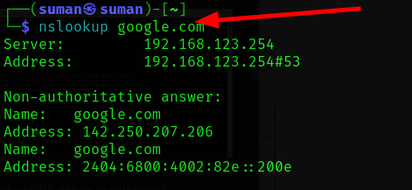

* **traceroute**

The ‘traceroute’ command is used to trace the route that packets take from our computer to a destination ip address . It provides information about the network hops between the source and destination.

Here the basic syntax :-

**Sudo traceroute <domain or ip address>**

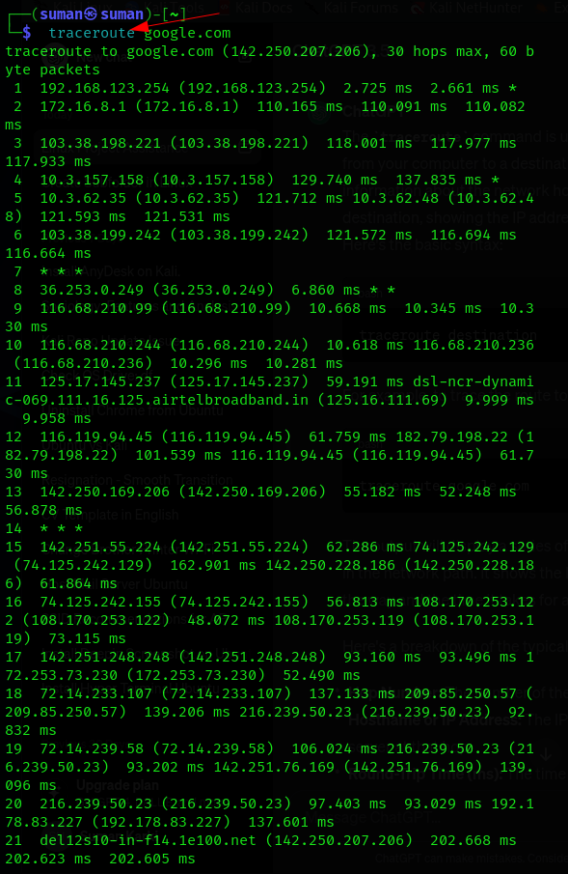

Here the basic information of the output :-

* Hop number

The leftmost column indicates the hop number(30) in the route .

* Hostname or ip address:-

The route start from my local machine (192.168.123.254) to the final

destination (142.250.207.206) which belongs to Google.

* latency

The round-trip times vary at each hop, reflecting the network latency.